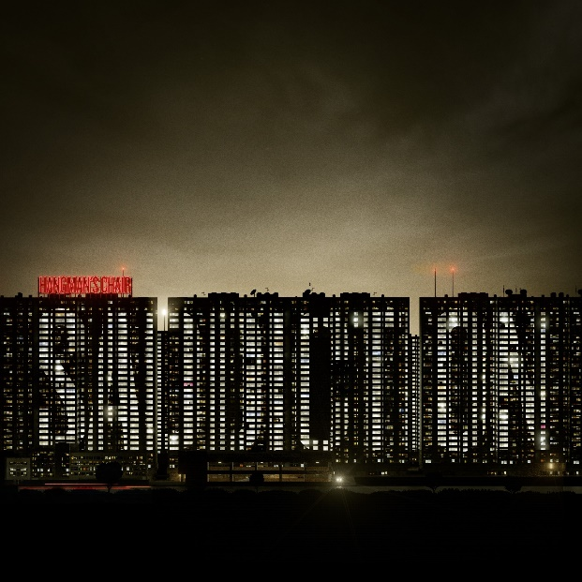

**HANGMAN´S CHAIR**

***Saddiction  
  
February 14th 2025***

|  |  |
| --- | --- |
|  |  |
| **Line up:** Julien Chanut - Guitar Cédric Toufouti - Guitar, Vocals Mehdi Thepegnier - Drums Clément Hanvic - Bass |  |

***HANGMAN'S CHAIR****, formed in 2005 in Paris, are one of the most unique sounding Doom Rock bands currently active. Through the years, they have found and fine-tuned their own sonic brand, somewhere at the crossroads between* ***TYPE O NEGATIVE****,* ***LIFE OF AGONY*** *and* ***SISTERS OF MERCY****, to name a few, mixed with a certain street credibility connected to the group’s roots in hardcore. Each album takes its strength and essence from the band members’s life experiences, which they portrait with unflinching honesty. Whether it is the loss of band members, drug overdoses or the hardships of living in suburban Paris, all those human emotions resonate within each of their songs asthey embrace the darkness and transform it into something beautiful, heavy and melancholic.*